RGF Introduces UPCO Qr Ultimate Photocatalytic Oxidation In-Duct Air Purifying System

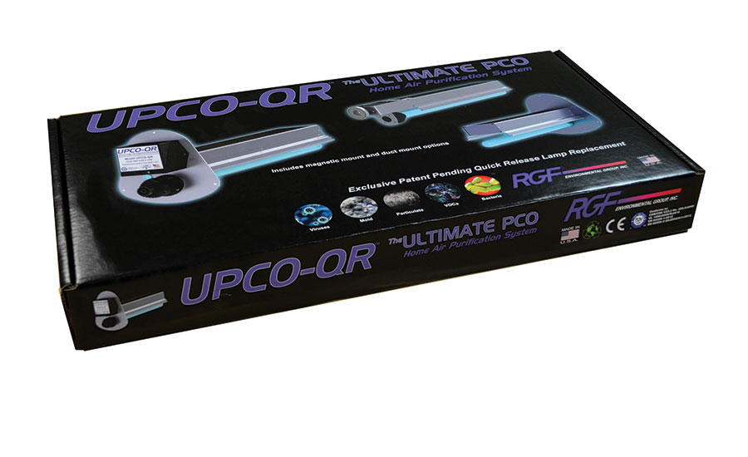

RGF Environmental Group Inc. has introduced its latest product for the HVAC/IAQ industry. The patent-pending UPCO QR™ photocatalytic oxidation in-duct air purifying system reportedly has the lowest pressure loss, highest surface area and most competitive price compared with similar PCO products in the HVAC/IAQ marketplace.

The combination of technologies incorporated into the UPCO QR™ work to create RGF’s low-pressure-loss, pure-carbon-infused bed. By combining titanium dioxide, silver, copper and zinc metal into this proprietary dual-catalyst bed, the system traps and reduces common indoor air pollutants. VOCs, bacteria, viruses, mold spores and odors are effectively diminished as air cycles repeatedly through the HVAC system, resulting in improved IAQ for both residential and commercial applications.

The UPCO QR™ was created to fill the mid-level space between RGF’s recently introduced BLU QR® UV Stick Light and the REME HALO® IAQ in-duct air purifier. The contemporary features are designed for quick installation and maintenance. The standard 24 VAC ballast makes installation easy. It comes standard with two mounting options in the box, including an easy-to-install magnetic mount and surface mount. The quick-release lamp allows for hassle- free, no-tools lamp replacement. The UPCO QR™ comes with a standard two-year warranty on both the ballast and UV lamp.

From：https://www.achrnews.com/articles/138674-rgf-introduces-upco-qr-ultimate-photocatalytic-oxidation-in-duct-air-purifying-system